Festival
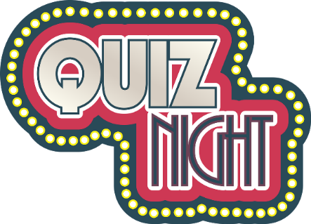

2025

PLEASE COMPLETE THIS FORM AND RETURN TO:

THE EVENTS OFFICE, ELSTREE AND BOREHAMWOOD TOWN COUNCIL, FAIRWAY HALL, BROOK CLOSE, BOREHAMWOOD, WD6 5BT

OR

EMAIL: dsalter@elstreeborehamwood-tc.gov.uk

YES, I WOULD LIKE TO ENTER A TEAM FOR THE QUIZ EVENING ON

TUESDAY 1 JULY 2025 AT THE ROYAL BRITISH LEGION CLUB,

SHENLEY ROAD, BOREHAMWOOD, WD6 1TG (next to St Teresa's Church)

(DOORS OPEN 7PM) Starts prompt 7.30pm

MAXIMUM OF FIVE PERSONS PER TEAM

NAME OF QUIZ TEAM:..............................................................................

CONTACT NAME: ....................................................................................

ORGANISATION: .......................................................................................

ADDRESS:………………………………………………………………….........
..............................................................................POST CODE:................

PHONE:………………………… E-MAIL:……………………………………

THERE IS LIMITED TABLE SPACE AVAILABLE -
WE WILL CONTACT YOU TO CONFIRM YOUR PLACE

